TEMPLATE
Relationship investigation
(Scatter graph)

Explore data using a statistical inquiry process (Internal)
NCEA Level 1

AS 91944
5 credits



1. Problem

How to use this template
For the 1.1 assessment, you will complete an investigation and write a report. The report you write will follow the PPDAC structure.
- Problem
- Plan
- Data
- Analysis
- Conclusion
If you are using this template, you have chosen to investigate the relationship between two numerical variables using a scatter graph.
In the green boxes there is space for you to complete your report. The sentence starters are there to guide you, but you don’t have to use them.
In the red boxes there is an example report, written to excellence level.
The text that has been written in orange is key information to include for excellence, but may not be strictly necessary for students just trying to pass.
Investigative Question:
This report will investigate the relationship between [numerical variable 1 (unit)] and [numerical variable 2 (unit)] out of [population].
The explanatory variable is [numerical variable 1 (unit)].
The response variable is [numerical variable 2 (unit)].
This report will investigate the relationship between height (m) and weight (kg) out of all All Blacks players and Springbok players in the 2012/2013 season (from the NZGrapher dataset).
The explanatory variable is height (m) of the rugby player.
The response variable is weight (kg) of the rugby player.
Background/purpose:
- What made you interested in studying this investigation?
- What is the purpose of the investigation - who will it be useful for?
- How widely could your results be applied?
For excellence, also include evidence of outside research.

I chose to do this investigation because I play rugby and wonder whether there would be a relationship between heights and weights of rugby players in my team.
The results could be useful for training/scouting staff for international rugby teams when making selection decisions. In particular, it could help them recognise when a player is underweight compared to other players of the same height, and try get them to build more muscle through a training regime.
Since the data only relates to NZ and South African players, it might be difficult to extend the results to other countries. For example, according to the Japanese national team squad lineup in 2025/2026 (https://www.ultimaterugby.com/japan/squad) the Japanese rugby side has an average height of 1.83m (71.42 / 39). This is lower compared to the average height of the Springbok side of 1.88m in 2025/2026 (93.88 / 50) (https://www.sarugby.co.za/sa-teams-players/springboks/). This might mean that my results can only be applied for All Blacks and Springboks, and not other countries’ national teams.
Also, the data is from 2012/2013 which might made it difficult to apply to today’s rugby sides. However, I wouldn’t expect players’ heights/weights to change too much between then and now.
Hypothesis:
- What might you expect to find in your investigation, and why?
I’m expecting that there will be a [weak/moderate/strong], [positive/negative] relationship between [numerical variable 1 (unit)] and [numerical variable 2 (unit)].
This is because…
I’m expecting that there will be a moderate positive relationship between rugby players’ heights and weights.
I think it will be a positive relationship because, according to sources like https://eujournal.org/index.php/esj/article/view/8891, people in general tend to be heavier if they are taller, and this makes sense.
I think it will be a moderate relationship and not strong, because different rugby positions have different height/weight requirements.
2. Plan
Collection of data
- What source did you get the data from, or how did you collect it (and was it collected fairly/properly)?
- Is the data likely to be reliable?

The dataset is from the NZGrapher ‘Rugby’ dataset. It is real data collected by rugby website ‘RugbyHow’ for the 2012/2013 season.
It is difficult to know whether the data is reliable because RugbyHow isn’t an official/government website. We don’t have any information on how it was collected (for example whether reserve players were included). However, because the data can easily be recorded/checked using other internet sources, I believe it will be reliable.

Cleaning the data
- Was any ‘cleaning’ of the data required? (‘Cleaning’ is only required for data which was obviously recorded wrong or was incomplete).

No cleaning of the data was required because there wasn’t any incomplete data, and none of the data appeared to be incorrectly recorded.

Sampling
- Did you take a random sample of the dataset (i.e. only include, say, 30 data points)?

Out of the total population of 154 players I took a random sample of 50 players. I used the ‘random’ sample tool on NZGrapher to do this. Taking a random sample helped ensure there’s no bias in how the data is sampled.
Sources of variation
- Discuss at least two of the following sources of variation:
  - Natural/real variation
  - Occasion-to-occasion variation
  - Measurement variation
  - Induced variation
  - Sampling variation (only if you took a sample)
- How did you manage those sources of variation?

There might be occasion-to-occasion variation, which means that the same player might have a different height/weight each time their measurement is taken. This could be due to weight/diet changes throughout the season. To manage this variation, the data only looks at players at a particular point in time during the 2012/2013 season. We don’t know exactly when the data was taken but we can assume it was all done at the start of the season, so this variation should be managed.
Another type of variation is measurement variation. This is the variation that occurs because there might be differences in how a player’s height/weight is measured, like different measuring equipment and methods. For example, whether the player was weighed with his clothes on or not. This variation is somewhat managed because International Rugby should have clear rules around how players’ heights and weights are measured, so there should not be too much measurement variation.

3. Data
For help with drawing the graph on NZGrapher, see here.
Copy and paste your Scatter Graph from NZGrapher (or other) here. Make sure it includes:
- a title;
- labels on each axis;
- units;
- summary statistics;
- a line of best fit (note: this can be done on NZGrapher [‘regression’], but depending on what your teacher wants, you might have to draw a line of best fit yourself, by eye).

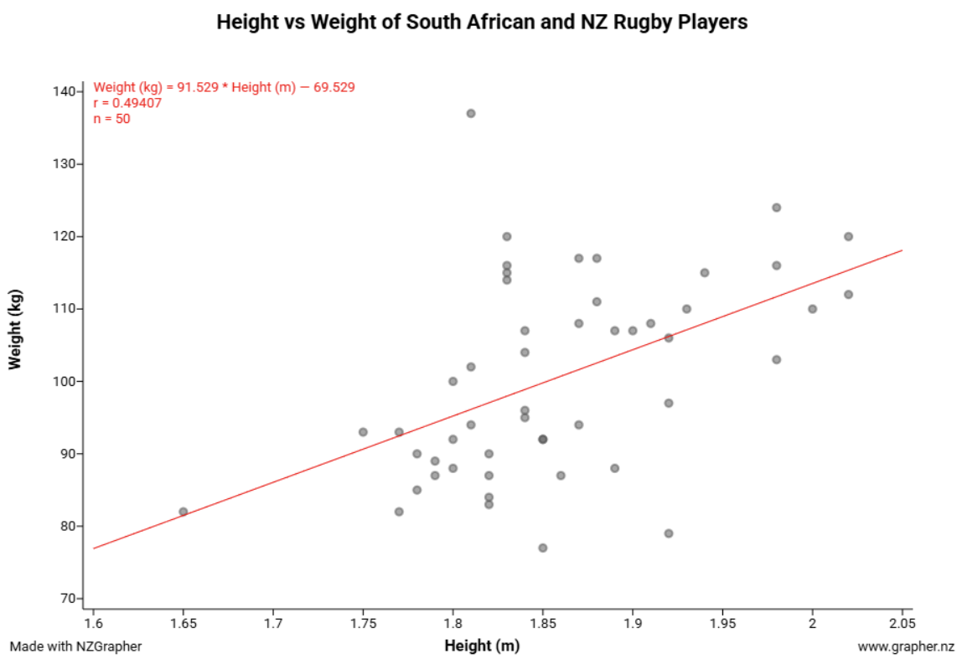

4. Analysis – Scatter Graph
Trend:
For trend, I notice that there is a [positive/negative/neutral] relationship between [numerical variable 1] and [numerical variable 2].
My evidence for this is that the line of best fit is [sloping upwards/sloping downwards/flat].
This means that, as [explanatory variable] increases, the [response variable] tends to [increase/decrease/remain the same].
(optional) This [is/is not] what I expected because…
(optional) This [makes sense/does not make sense] because…

I notice that there is a positive relationship between the height and weight of Springboks & All Blanks in the 2012/2013 season.
My evidence for this is that the line of best fit is sloping upwards.
This means that, as the height of players increases, their weight tends to also increase.
This is in line with what I expected, as it follows the general rule that taller people tend to be heavier. It makes sense that it would also be true for rugby players.
Direction:
I notice that the relationship between [numerical variable 1] and [numerical variable 2] is [linear/non-linear].
My evidence for this is that the line of best fit is [a straight line/not a straight line].
This means that, as [explanatory variable] changes, the [response variable] tends to change at a [constant/non-constant] rate.
(optional) This [is/is not] what I expected because…
(optional) This [makes sense/does not make sense] because…

I notice that the relationship between the height and weight of Springboks & All Blacks in the 2012/2013 season is linear.
This can be seen on the graph as the line of best fit can be drawn as a straight line.
This means that, as the height of players changes, their weight tends to change at a constant rate (rather than an exponential rate).
I do not know what I expected the direction to be, but a linear relationship does seem to make sense.

Strength:
I notice that the relationship between [numerical variable 1 (unit)] and [numerical variable 2 (unit)] is [weak/moderate/strong].
My evidence for this is that the data points are [very scattered / moderately scattered / tight] around the line of best fit.
This means that, we can [not be very confident/ be somewhat confident / very confident] about make we predictions about [response variable] based on [explanatory variable].
(optional) This [is/is not] what I expected because…
(optional) This [makes sense/does not make sense] because…

I notice that the relationship between the height and weight of Springboks & All Blacks in the 2012/2013 season is a weak relationship.
My evidence is that the data points are very scattered around the line of best fit. For example, just between the 1.8 – 1.85m range, the highest weight is 137kg and the lowest weight is 81kg. This is a lot of spread.
This means that we cannot be as confident when making predictions about what weight a rugby players in the dataset will have based on their height.
This is not what I expected because I was expecting the relationship to be moderate, not weak. I must have underestimated just how different the weights of players would be depending on their rugby position. I’m guessing that the lighter players tend to be wingers/backs and the heavier ones tend to be props/forwards.

Unusual Features:
- Any outliers?
- Any changes in variation?
- Any clusters?

I notice that there is an outlier who is 1.82m tall and 137kg. This is an outlier because it is very far away from the line of best fit, compared to other data points. This player is very heavy for their weight, so it’s likely that they play a forward position.
There aren’t any obvious clusters or changes in variation.

Prediction:
Using our regression formula from NZGrapher, we can make a prediction about [response variable] based on [explanatory variable].
Regression formula: [Regression formula from NZGrapher]
[Make prediction – see example in red box below]
Using our regression formula from NZGrapher, we can make a prediction about what a player’s weight will be based on their height.
Regression formula: Weight (kg) = 91.529 x Height (m) – 69.529
For a player who is 1.9m tall, their weight would be 91.529 x 1.9 – 69.529 = 104.38 kg
As mentioned earlier, because the relationship is weak, we can’t be too confident in our prediction as there is a lot of variation.

5. Conclusion
Summary of analysis:
- Repeat investigative question.
- Summarise analysis.
My investigative question was ‘what is the relationship between [numerical variable 1 (unit)] and [numerical variable 2 (unit)] out of [population]?’
Overall, I have found that there is a [weak/moderate/strong], [positive/negative/neutral] , [linear/non-linear] relationship between [numerical variable 1 (unit)] and [numerical variable 2 (unit)] out of [population].
My investigative question was ‘what is the relationship between height (m) and weight (kg) out of all All Blacks players and Springbok players in the 2012/2013 season (from the NZGrapher dataset)?’
Overall, I have found that there is a weak, positive, linear relationship between height (m) and weight (kg) out of all All Blacks players and Springbok players in the 2012/2013 season (from the NZGrapher dataset).

Sampling variability (optional – only if you took a sample):
My analysis was based on a sample of [X] out of the population of [population size]. Because of sampling variability, if I were to take another sample of the same population, it is possible that I would get different results. However, because I took a large sample, the results will probably be roughly the same.
My analysis was based on a sample of 50 out of the dataset population of 135. Because of sampling variability, if I were to take another sample of the same population, it is possible that I would get different results. However, because I took a large sample, the results will probably be roughly the same.

Reflection:
- Was your hypothesis correct? Why or why not?
- What reflections do you have on the process?
- What else would be interesting to investigate (connected to what you investigated)?
- Are there any limitations to your investigation (and how widely your results can be extended)?
NOTE: This ‘reflection’ part is an important part of the criteria for getting excellence in this assessment. Try to show a deeper understanding of your results, think carefully about how they could actually be used, and talk about what biases/limitations might be at play.

Overall, my hypothesis was only partly correct about there being a moderate, positive relationship between the height and weight of All Blacks players and Springbok players in the 2012/2013 season.
The relationship turned out to be weaker than I thought. This is likely to be because of different rugby positions having different roles on the field and therefore having different weight requirements. This matches up with sources, for example in https://blog.networldsports.co.uk/rugby-union-positions-numbers-explained/ they explained that “The forwards are usually significantly larger and heavier, taller and have higher levels of body-fat relative to the backs, and use their size to gain ground, win possession of the ball in scrums and line-outs.”
In the future, it would be interesting to investigate the relationship between height vs weight for forwards, and also the relationship between height vs weight for backs. I think this would have revealed interesting information about how the measurements change based on field position. This would probably make the results more useful for coaches/scouts of international rugby teams.
One reflection I have on the process is that it might have been better to look at all international rugby teams, not just All Blacks and Springboks. This is because different nationalities have biological differences which mean that their players have different builds. This can be seen on this statistics website which shows that the average height of boys ranges from 160cm (Timor-Leste) to 184cm (Netherlands) - https://worldpopulationreview.com/country-rankings/average-height-by-country.
Some limitations for this analysis is it might not be useful for amateur rugby coaches because the build of professional athletes is likely to be different to amateur rugby players. It might still be useful for provincial rugby competitions and Super Rugby because those players are professional. Another limitation is that the results are limited to being relevant to Springboks and All Blacks, not all countries.

